Physical Development skills
Use different equipment to juice different fruits
To hold the pencil correctly using a tripod grip.
To begin to form numbers and familiar letters, e.g. letters in their name.
To look at books independently whilst turning pages one at a time.
Using balancing apparatus.
To mark make using a comfortable grip when using pencils and pens.
Knowledge
To know that the pencil needs to be held comfortably and with one hand to form letters and numbers.
To know how to use one handed tools effectively.
To be able to follow a simple sequence of movements to music and rhythm.

PSED skills
To show independence in accessing and exploring the environment.
To independently put on coats and use the toilet.
To listen to, and follow rules set.
To learn to look after resources within the class.
Knowledge
To be aware of the different areas in the Nursery and how to explore them safely.
To approach an adult if they need support.

Communication and language Spring 2skills
To listen to stories and retain key vocabulary.
To be able to talk about the setting, characters and the structure of the story.
To be able to use connectives e.g. Once upon a time and then.
To listen to, and follow simple instructions and respond to questions appropriately.
To talk in short sentences that others can understand.
Knowledge
To know that stories have a beginning, middle and an end.
To be able to answer questions related to the story. To be able to understand simple instructions, questions and commands.

Spring 2

Maths skills
To identify, describe and compare groups of objects.
To develop fast recognition of numbers 1-5.
To count up to 10.
To subitize 1-3 To start to use language such as 2 at the top, one at the bottom, 3!
Show finger numbers to 3.
To independently create and talk about own patterns using a range of objects and resources.
Knowledge
To subitise to 3.
To know number order beyond 5 when counting.
To use the language of more and less to compare amounts.
To know that numbers can be ordered.
To be able to demonstrate through games and role play an understanding of positional language.
Singing a range of number songs.

Literacy skills
To be able to mark make and give meaning to their marks.
To identify the pictures linked to RWI sound.
To begin to form some letters correctly, e.g. letters in their name.
Knowledge
To be able to talk about their marks with confidence.
To talk about the sounds they have identified from the RWI program.
To join in with repetition within stories.
To be able to talk about different parts of the story.
RWI Speed sound lessons.
Fred talk – verbally segmenting and blending.

Understanding the world Skills

To investigate different fruit using their senses,
To investigate how to make juice out of fruit.
To talk about fruits we have at home.
To understand that people have different lives to us
To talk about the different fruits starting to use a wider vocabulary- avocado, mango, juicy, sweet, sour, creamy
To understand we use our senses to investigate fruits in different ways.
To understand that Easter is a celebration and we may have family traditions.

Knowledge
To say what they use to smell, taste, feel etc.
To know the story of Easter
To know that Handa is from Africa
To know that Handas environment is different to ours, to identify some differences
To know the names of some unfamiliar fruits
To know that orange juice can be made from oranges/ lemon juice from lemons etc
To know that some fruits come from warm countries.

Expressive arts and design skills
To learn about different textures and talk about them.(Art Link)
To talk about patterns.
Create with a purpose in mind- musical instruments handas
Feely bag activities with different objects for children to feel and describe.(Art Link)
To engage in role play by making stick puppets of different story characters. (DT/Art Link)
Sing familiar Nursery Rhymes.(Music Link)
Realises tools can be used for a purpose. (DT Link)
To create closed shapes with continuous lines which represent objects that can be spoken about or identified.
Knowledge
To know about the different materials and what can be created with them.
To use their knowledge of stories in acting them out with friends. (Art Link)
Sing songs clearly using correct words that have been learned. (Music Link)
To know how to create recognisable representations of objects. (Art Link)

Theme | Our World. A different place  Mothers day  Easter- planting |  | 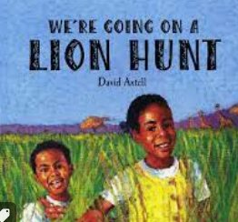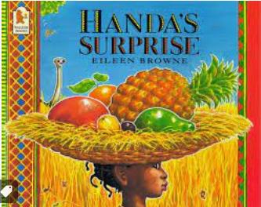 |  |  | Trips/ visitors-
 |  |  |  |  |  | Key vocab : surprise, delicious, soft, sweet, juicy, ripe, spikey, creamy, tangy. Africa
PSED | Communication and language | Physical |  | Literacy | Maths |  | Understanding the world | Expressive arts
 |  |  |  | Lion hunt Discuss title- have we heard this before?  Read and discuss initial reactions and observations  Learn the story |  |  | Handas- homes in other cultures. Food in other cultures  Show children an image of Naresiah, he wants to be your friend, he lives in Africa, stick his picture on Kenya on world map and stick ours on England, does he live close or far away?  Show picture of his house, is it the same or different as ours? It is made of sticks, mud and cow dung!!! Watch video. Stop at ‘this is my mum she makes me happy’ is this the same or different to us? Our family make us happy too. Could the 3 little pigs live in his house even though it is made of sticks?  https://www.youtube.com/watch?v=XQ7wV9DeEqw  journey/ map of handas journey  bear hunt/ lion hunt- journeys –  visiting handa- transport look at old/ new aeroplanes  learn about lions  fruit tasting | Handas- fruit printing  Handas- African patterns/ art. Colour mixing  African music https://www.youtub e.com/watch?v=9b 81mWYIyTo  https://www.yout ube.com/watch?v= hIdp_Nj0tgk  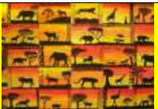Using paints or crayons make a background using sunset colours (yellows, orange, reds, pinks and purples). U
To learn about Easter. (RE Link)
Children to talk about significant events in their life.
(History Link)
To know that there are different countries in the world, (Geography Link)
To know that there are different countries in the world and talk about the differences they have experiences or seen in photos,(Geography Link)
T

Shows skill in making toys work by pressing parts or lifting flaps to achieve effects such as sound, movement or a new image (Computing Link)

