Communication and language Autumn 2 skills
To listen to traditional stories and retain key vocabulary.
To be able to answer questions and share opinions using the relevant vocabulary.
To be able to talk about the setting, characters and the structure of the story.
To be able to use connectives e.g. Once upon a time and then.
Knowledge
To know that stories have a beginning, middle and an end.
To be able to answer questions related to the story.
To be able to use vocabulary learnt to have a conversation with others. To be able to answer questions related to)To be able to use vocabulary learnt to have a conversation with others.

Physical Development skills
To hold the pencil confidently, using the tripod grip and forming letters and numbers mostly correctly
To be able to use scissors confidently and make straight, zig zag and circular snips using one hand.
To run skilfully and be able to negotiate space.
To mark make using a comfortable grip when using pencils and pens.
Knowledge
To know the correct ways of forming letters.
To know that snips should be made on the line and the pattern should be followed.
To know how to feed paper/materials through hand when cutting around objects.
To be aware of obstacles whilst running, riding a scooter/bike etc and display some spatial awareness.

PSED skills
To be able to initiate play with peers and keep play going by giving ideas.
To become more outgoing with unfamiliar people.
To show more confidence in new social situations.
To begin to find solutions to conflicts.
To show an awareness of how others may be feeling.
Knowledge
To know that to play nicely it’s important to share and take turns.
To know that if I am upset, I can use phrases such as “stop it, I don’t like it” to convey my discomfort.
To know that it is OK to engage with others, even if in a different environment.
To know that people show their emotions in different ways, for example smiling if they are happy, cry if they are sad etc.

Summer 1

Literacy skills
To identify the pictures linked to RWI sound.
Children will begin to identify some sounds during oral blending games.
To begin to make predictions about a story, sometimes supported by an adult with vocabulary.
Knowledge
To know that blending sounds makes words.
To identify the pictures with corresponding.
To join in with repetition within stories.
To be able to talk about different parts of the story.
RWI: Continue to introduce two sounds a week.
Introduce writing sounds.
Fred talk – physical cards available.
HA – Introduce one sound per day and introduce 1.1 green words.

Understanding the world Skills
Talk about the life cycle of a plant and animals.
(Science Link)
To use senses to explore the world around them.(Geography/ Science Link)
Children to talk about significant events in their life with confidence.(History Link)
Talk about the life cycle of a plant. (Science Link)
To use the ipad to complete a simple task.(Computing Link)
To listen to traditional stories such as Jack and the Beanstalk and talk about plants. Plant their own seeds and check how tall the plants grow. (Science Link)

Knowledge
To know that every living being has a life cycle and they change in shape and size as they grow.(Science Link)To know that living beings follow a similar growth pattern and make comparisons. (Science Link)
To begin understand the importance of looking after our environment and all living things and where we can collect natural resources from. (Science/ Geography Link)
Knows how to operate simple equipment. (Su1)
(Computing Link
Maths skills
Practical problem solving with numbers up to 5.
To select and use shapes appropriately in play, combining them to make models and enclosures.
To develop fast recognition of numbers.
To use relevant mathematical vocabulary when talking about learning.
To begin to make sensible comparisons between objects relating to size, length, weight and capacity.
To begin to describe a sequence of events accurately.
To recall simple facts about a familiar journey.
Knowledge
To subitise to 6.
To remember the order in which things happen.
To know that subtraction means taking an amount away from a group.
To know that some shapes more appropriate than others when building.
To remember different aspects of a journey, e.g. “I walked over a bridge to get to school”.

Expressive arts and design skills
To make masks for role play. (DT/Art Link)
Sing familiar songs in the correct tone and changing melody if appropriate.(Music Link
Uses available resources to create props to support role-play.
(DT/Art Link)
To use available props to develop stories and make imaginative play more purposeful.(DT/Art Link)
To show different emotions in pictures clearly.(Art Link)
To draw with increasing control, representing features and detail clearly. Art/PE Link
Knowledge
To know how to use props appropriately for particular stories.(Art/DT Lin
To know that they can change their voices whilst singing or acting out stories to create a dramatic effect.(Art/Music Link)
For children to be able to construct with a purpose and safely.
(DT Link)
To know how to use available props to develop stories and make imaginative play more purposeful.(Art/DT Link)

Theme | Minibeasts/  Growing  Ocean week | 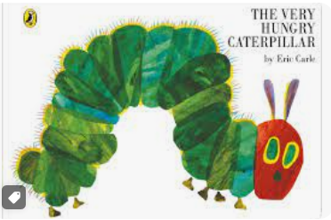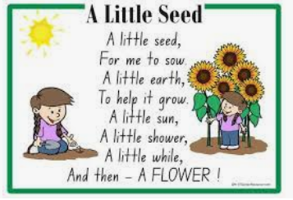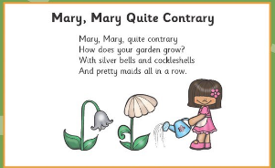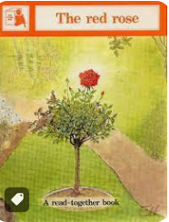 |  |  |  |  | Trips/ visitors-
PSED | Communication and language |  | Physical | Literacy | Maths | Understanding the world |  | Expressive arts
Caterpillars insect lore order to be dispatched on 14.04

Fruit tasting, compare to handas

