Communication and language Autumn 1 skills
To sing rhymes and look at picture books.
To talk about the different characters and what they are doing.
To talk about themselves and their families.
Develop communication that can be understood by others.
Know many rhymes
Use a wider range of vocabulary
Can start a conversation with an adult or a friend
knowledge
To know that stories have different characters.
To know to sing words clearly so that they are audible.
To know that it is OK to talk to others about wants and needs.
PSED skills
To separate from main carer and learn to adapt to the Nursery environment.
To select and use activities and resources, with some support if needed.
To start to play with 1 or more other children
To join in with a few routines e.g. snack and story
Knowledge
To know that they can approach adults in Nursery when needed.
To know what resources they are allowed to access

Physical Development skills
To start to take care of toileting needs independently.
To begin to show a preference for a dominant hand.
To climb apparatus safely.
To begin to show awareness of moving equipment safely with peers.
To wash hands after using the toilet.
To show an awareness of the importance of oral health.
Knowledge
To know about oral and personal hygiene and the importance of being clean and tidy.
To know that washing hands is important after using the toilet and before we eat.
To know that books in English should be read from left to right and one page at a time.
To use alternate feet when climbing apparatus.
To show independence with eating and drinking, e.g. being able to feed self and ask for help with opening containers.
To know that oral hygiene is important and also know that eating fruits and vegetables is healthy for teeth and our bodies.

Autumn 1

Literacy
Reading
Understand the five key concepts about print:
- print has meaning
- print can have different purposes
- we read English text from left to right and from top
to bottom
- the names of the different parts of a book
- page sequencing
Writing
To distinguish between the different marks they make
To become confident using different mark making tools
RWI:
Fred talk games

Understanding the world Skills
To be able to talk about their body parts and what the function is of each part. (Science Link)
To draw silhouettes and orally label body parts. (Science Link)
To be able to identify similarities and differences between themselves and peers. (History Link)
To make self-portraits.(History Link)
Children to begin to talk about significant events in their life.
(History Link)
To talk about the order of daily routines e.g. putting mealtimes in order. Basic daily routine in order. (history link)

Shows skill in making toys work by pressing parts or lifting flaps to achieve effects such as sound, movement or a new imag
To explore collections of autumn materials and notice similarities and differencese.g. leaves/ weather
To sort toys into baby toys and toys I play with today. history
Spend time looking at photos of myself and my family To talk about my family- history

Knowledge
To know about family structures and be able to talk about who is part of their family.(History Link)
To begin to talk about what they see outdoors using some new vocabulary.(science)
Shows an interest in technological toys.
(Computing Link)

Maths skills
To talk about what happened today, yesterday and tomorrow.
To join in with number songs
To count out loud to 5 confidently
To subitize to 1 and 2 confidently.
Knowledge
Singing a range of number songs.
To say number names to 5 in order.
To know that time can be measured using days.
To know that the last number said represents the total number of objects
To show an awareness and name some 2D shapes in the environment.

Expressive arts and design skillsListening to and join in with Nursery rhymes and use musical instruments to tap out a rhythm. (Music Link)
To learn about colour mixing for different arts linked to nursery rhmes.
Uses various construction materials.(DT Link)
Knowledge
To know that different musical instruments make different sounds and to differentiate between the sounds, sharing thoughts and feelings about what they have heard.(Music Link)
For children to be able to construct with a purpose and safely.(DT Link)

Autumn 1 curriculum
Theme | Me and my family/ seasons | Our favourite nursery rhymes/ stories /  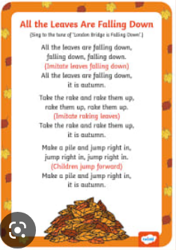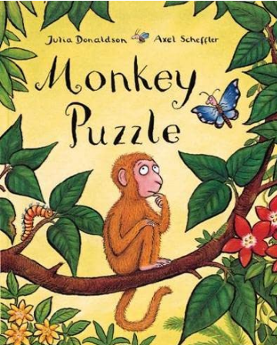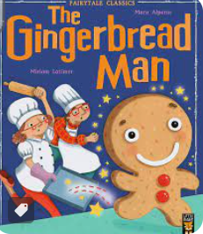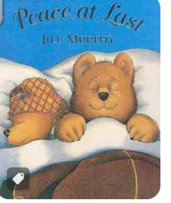 |  |  |  |  | Trips and experiences- autumn walk, local area walk
PSED | Communication and language |  | Physical | Literacy | Maths | Understanding the world |  | Expressive arts
Have a range of provision which supports children’s interests.  Clear morning routine to settle children in and feel safe leaving caregiver, coat on peg, classroom for reading/ funky finger activity.  Terry turtle rules  Visual timetable | Join in with our favourite nursery rhymes. 1 a week. Learn rhyme and do storymaps, actions.  Focus in provision on using words instead of noises when a child wants something or someone takes a toy etc. |  | Hang my coat up  Start potty training  Adult support toileting if needed then Start going to the toilet independently.  Oral hygeine | Learn and start to join in with some nursery rhymes (childrens favourites) . discuss characters in rhymes and describe.- link to history if poss- old/ new teapots etc  Read ‘Monkey puzzle’. Shorten if necessary. Start to join in with ‘no, no no, that’s….’  Fred games touch you t-oe-s etc  Gingerbread man (see plans) | Focus on numbers 1, 2 and 3.  Number songs | To talk about me, favourite stories, rhymes, toys.  To talk about my family. Make marks to represent my family.  Autumn  Song sutumn leaves are falling down  Natural resources collecting leaves, conkers, helicopters  ‘I wonder why these leaves are different colours?’  ‘ wonder what is inside this spiky shel’’I wonder if these autumn treasure float or sink?’l  What do we wear  Simple map of autumn walk  Hibernation  Look at separate planning for monkey puzzle |  | Start to draw circles to draw my face.  Draw around my hand/ body.  Point to body parts ‘if youre happy and you know it…’  Heads shoulders knees and toes  Use different musical instruments when singing nursery rhymes

