Physical Development skills
To independently put on their coats, with some support for the zipper and buttons.
To copy dance moves and to move to different kinds of rhythms.
To use mark making resources with increasing independence.
Knowledge
To show confidence in dressing up and self-care activities.
To know how to move on different beats and rhythms e.g. slowly for slow music and fast on quicker beats.
To know how to use mark making resources effectively, e.g. how to use scissors to snip or how to use a paint brush to paint.

PSED skills
To learn about daily routines and classroom rules.
To be aware of behavioural expectations in the Nursery.
To select and use activities and resources, with some support if needed.
Knowledge
To know how to adapt behaviour to suit classroom routines.
To show confidence in asking adults for support.

Autumn 2
Communication and language Autumn 2 skills
To talk about celebrations at home.
To listen to stories on celebrations such as birthdays, Diwali, Christmas, etc and to talk about them and why they are celebrated.
To listen to, and follow simple instructions.
Knowledge
To start to know that stories have a beginning, middle and an end.
To be able to understand simple instructions.

Understanding the world Skills
To know that everyone has a birthday and they are usually celebrated in a similar manner around the world.(History Link)
To know that some celebrations are specific to some cultures, for example,
Diwali is usually celebrated by Hindu’s and Sikhs, Christmas is celebrated by Christians. (RE Link)
Children to begin to talk about significant events in their life.
(History Link)
Use IT hardware to interact with age-appropriate computer software.(Computing Link)
Knowledge
To make Rangoli patterns on the ipad.(Computing/RE Link)
To learn about the different stories related to Autumn festivals.
(History/RE Link)
Shows an interest in technological toys.
(Computing Link)

Literacy skills
To find and identify familiar letters, e.g. letters in their names.
To talk about and retell a range of familiar stories.
To begin to explore initial sounds in familiar words.
Knowledge
To know that letters are used to make up words.
To know that each letter makes a sound – focussing on initial sounds in their names.
To start to learn that stories have a sequence; beginning, middle and end.
To know that text is read from left to right and top to bottom in English.
To name and talk about the different parts of a book, e.g. front cover/ back cover/ spine/ pages
To begin to acknowledge initial sounds and their relevance in the environment

Maths skills
To count out a group of up to 5 objects.
To match number of objects to numeral to 3.
To show an understanding of 1:1 counting to 5.
Knowing that the last number you count represents the total number of objects
Subitize up to 3 objects
Talk about and explore 2D shapes using relevant mathematical vocabulary such as flat/sides/ round/ straight/ corners
Knowledge
To say number names to 10 in order.
To know that a group of objects can also be represented by a number
Singing a range of number songs.
To know that the last number said represents the total number of objects
To show an awareness and name some 2D shapes in the environment.

Expressive arts and design skills
Sing familiar Nursery Rhymes and Nativity songs. (Music Link)
To use different colours and materials to make Rangoli Patterns. (Au2)(Art Link)
To make salt dough Diva’s. (DT/Art Link)
To make Christmas cards and decorations for friends and family using a range of media. (DT/Art/RE Link)
To make patterns with paint and different objects, exploring what happens when you mix colours.(Art Link)
Joins construction pieces together to build and balance. (DT Link
Knowledge
To know how different colours and materials can be used to create things.(Art Link)
To learn about art and crafts from different cultures e.g. Rangoli patterns and divas are from India and Christmas is celebrated by Christians all around the world.(Art/RE Link)

Theme | Celebrations | 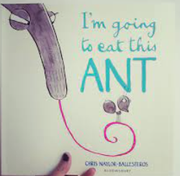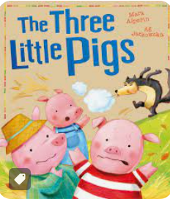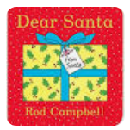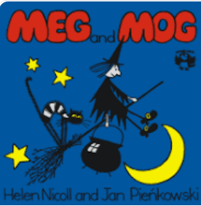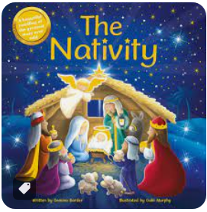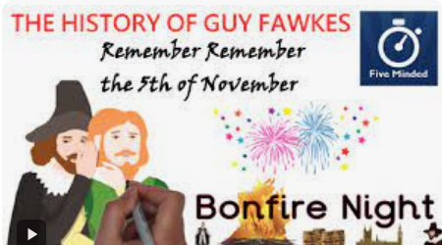 |  |  |  |  | Trips/ visitors- father Christmas
PSED | Communication and language |  | Physical | Literacy | Maths | Understanding the world |  | Expressive arts
Use visual timetable daily.  Make up a board game for megs journey with a dice to encourage turn taking adult led. | Spooky café  Look at pictures from home and discuss Christmas decorations, traditions |  | Dough disco themes- Halloween etc | Week 1- meg and mog  Week 2 bonfire night  Week 3- diwali  Week 4- dear santa- letters to santa royal mail  Week 5- nativity story |  | Diwali  Bonfire night  Halloween  Maps- what could meg see if she flies over Wallasey.  Old/ new, pictures of you at Christmas as a baby, toddler, now |  | Rangoli patterns  Diwa lamps clay  Bonfire night art

